Sexual Intercourse – Notes
- For sexual intercourse to take place, and for sperm to be deposited in the vagina, the penis must become enlarged and firm, a condition referred to as an erection.
- An erection results from blood rushing into spaces of the erectile tissue of the penis which is initiated by sexual excitation.
- When sexual stimulation of the penis within the vagina becomes sufficiently intense, rhythmic contractions of the epididymis, the vasa deferentia, the seminal vesicles and the prostate gland occur.
- These contractions propel the contents of the ducts and glands into the urethra and then out of the body – this process is called ejaculation.
- The ejaculated material consists of fluid (semen) which contains sperm.
- Accompanying ejaculation is a rapid heartbeat, an increase in blood pressure and breathing rate, and intensely pleasurable sensations; these reactions constitute an orgasm.
- Besides nourishment, semen provides the sperm with a fluid in which to swim and it also neutralises the acidic nature of the male urethra and female vagina; it also contains enzymes that activate the sperm once ejaculation has taken place.
- When the female is sexually stimulated, erectile tissue in the region of the vaginal opening fills with blood; this reduces the size of the vaginal opening and tends to increase the simulation of the penis during sexual intercourse.
- Arousal also results in copious secretions of mucus by glands located around the cervix and in the region of the vaginal opening; these secretions lubricate the epithelial lining of the vagina, allowing for easy entry of the penis.
- As sexual intercourse progresses, the external genitalia are rhythmically stimulated and, when sexual arouses reaches sufficient intensity, the female undergoes an orgasm, or climax.
- In a female orgasm, there many be an increase in the secretion of cervical mucus. A female doesn’t need to reach an orgasm for fertilisation to occur and it’s unknown whether female orgasm helps fertilisation.

Fertilisation – Notes
- Fertilisation – Secondary oocyte is joined to a sperm nucleus to form a diploid nucleus.
- Secondary oocyte is only able to be fertilised for one day after ovulation.
- Sperm remain viable for 1-3 days.
- Fertilisation can only occur if sperm is deposited into the female reproductive system (insemination) no earlier than 3 days prior to ovulation and no later than one day after ovulation (4-day window).

Fertilisation steps:
- The many sperm break down the corona radiata.
- Sperm break through the corona radiata and bind to zona pellucida.
- Sperm heads release enzymes which tunnel through the zona pellucida (acrosome reaction).
- The first sperm through and binding to the secondary oocyte loses its flagellum and is drawn into the oocyte cytoplasm.
- Secondary oocyte completes Meiosis II.
- Each nucleus of the oocyte and sperm head swell (pronuclei), rupture and both sets of chromosomes come together to form one nucleus – a diploid zygote.
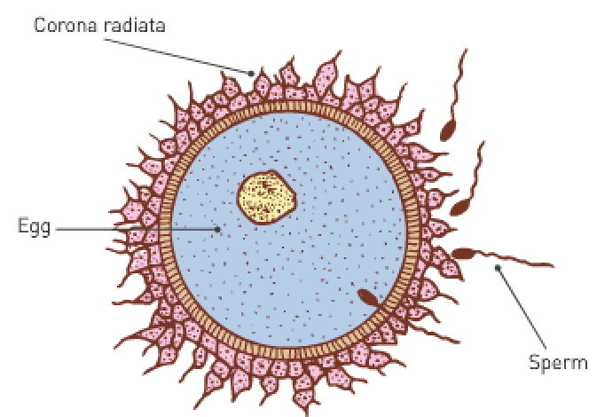

From zygote to blastocyst:
- The zygote takes 3-4 days to travel to the endometrium in the uterus.
- The zygote undergoes cleavage (many mitotic divisions) to create more cells for the formation of a morula.
- A blastocyst is formed around 4 days after conception.

The blastocyst consists of:
- An inner cell mass which later becomes embryo structures.
- A hollow fluid-filled cavity (called blastocoel).
- An outer layer of cells (trophoblast) which surrounds the fluid-filled cavity and allows the blastocyst to burrow into the endometrium (implantation). These cells grow into chorionic villi which then form the placenta.
- Implantation occurs 7 days after ovulation and allows the blastocyst to gain nourishment for growth and development by absorbing nutrients from the glands and blood vessels of the uterine lining.
- Implantation: The process of the blastocyst moving from the cavity of the uterus and sinking into the endometrium to become firmly attached to the wall of the uterus.
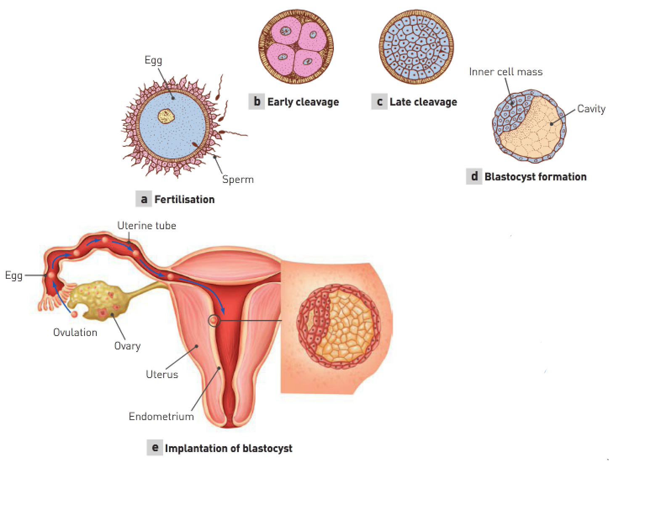
Hormonal maintenance of endometrium:
- The corpus luteum releases progesterone and oestrogen to maintain the endometrium until the placenta develops.
- Without blastocyst implantation, the corpus luteum would break down and FSH would be released by the pituitary to start the ovarian cycle.
- The trophoblast of the blastocyst has become the chorionic villi. Chorionic villi secrete HCG which maintains the corpus luteum.
- Note: Healthy embryo = health corpus luteum = healthy endometrium = sufficient nutrients for embryo.

Endometrium maintenance:
- The maintained corpus luteum (with high levels of hormones) keeps the endometrium lining from being shed and so the menstrual cycle ceases.
- The placenta takes 3 months to develop from finger-like projections of the chorionic villi. Once developed, it maintains the endometrium by releasing oestrogens and progesterone.

Primary germ layers:
- While the blastocyst is implanting in the endometrium, the inner cell mass undergoes changes resulting in the primary germ layers: the endoderm (inside), mesoderm (middle) and ectoderm (outside).
- These layers are the embryonic tissues that will differentiate into all the tissues and organs of the body.

Endoderm: | Mesoderm: | Ectoderm:
Lining of the alimentary canal and glands. | Skeletal, cardiac and smooth muscle. | Skin.
Lining of the respiratory system. | Cartilage, blood and bone | Hair, nails and sweat glands.
Lining of most internal organs. | Lymphatic tissue. | Nervous system.

Endoderm: | Mesoderm: | Ectoderm:
Epithelium of alimentary canal and its glands. | Skeletal, smooth and cardiac muscles. | Epidermis of skin.
Epithelium of urinary bladder, urethra and gall bladder. | Cartilage, bone, blood and other connective tissue. | Hair, nails, glands of skin.
Epithelium of pharynx, auditory canal, larynx, trachea, bronchi and lungs. | Lymphoid tissue. | Lens, cornea and muscles of the eye.
Epithelium of tonsils, thyroid, parathyroid and thymus glands. | Endothelium of blood vessels and lymphatics. | Receptor cells of the sense organs.
Epithelium of vagina and associated glands. | Epithelium of body cavity and joint cavities. | Epithelium of mouth, nostrils, sinuses, glands of the mouth and anal canal.
 | Epithelium of kidneys and ureters. | Enamel of the teeth.
 | Epithelium of ovaries, testes and reproductive tracts. | Nervous system.
 | Epithelium of adrenal cortex. | Anterior lobe of the pituitary gland.
 | Dermis of skin. | Adrenal medulla.

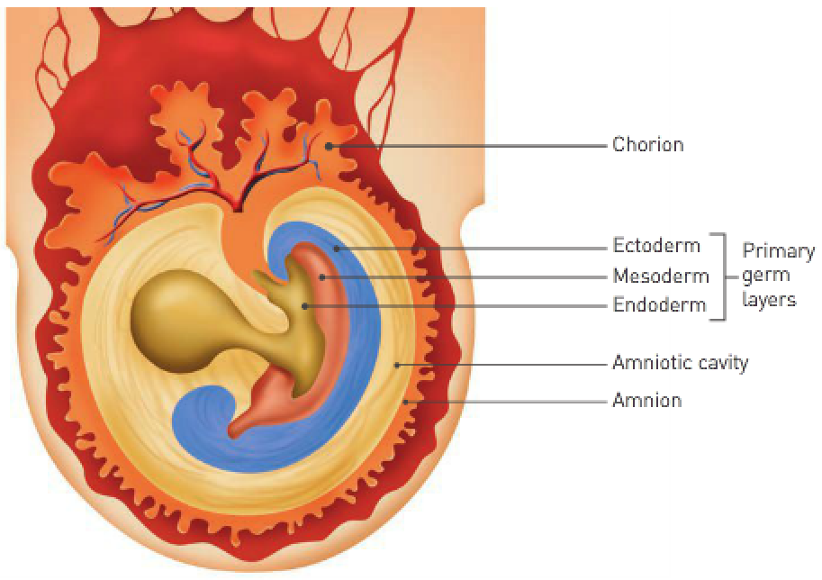
Embryonic membranes:
- Early in the embryonic period, 4 embryonic membranes form which serve to protect and nourish the embryo as it develops.
- Amnion: The first membrane to develop which encloses the embryo in a cavity into which it secretes amniotic fluid.
- Amniotic fluid serves to protect the embryo against physical injury by acting as a shock absorber; it also helps maintain a constant temperature and allows the embryo to move freely.
- Chorion: The fourth membrane to develop which surrounds the embryo and the other 3 embryonic membranes.
- As the amnion enlarges, it fuses with the inner layer of the chorion; eventually it becomes the main part of the foetal portion of the placenta.
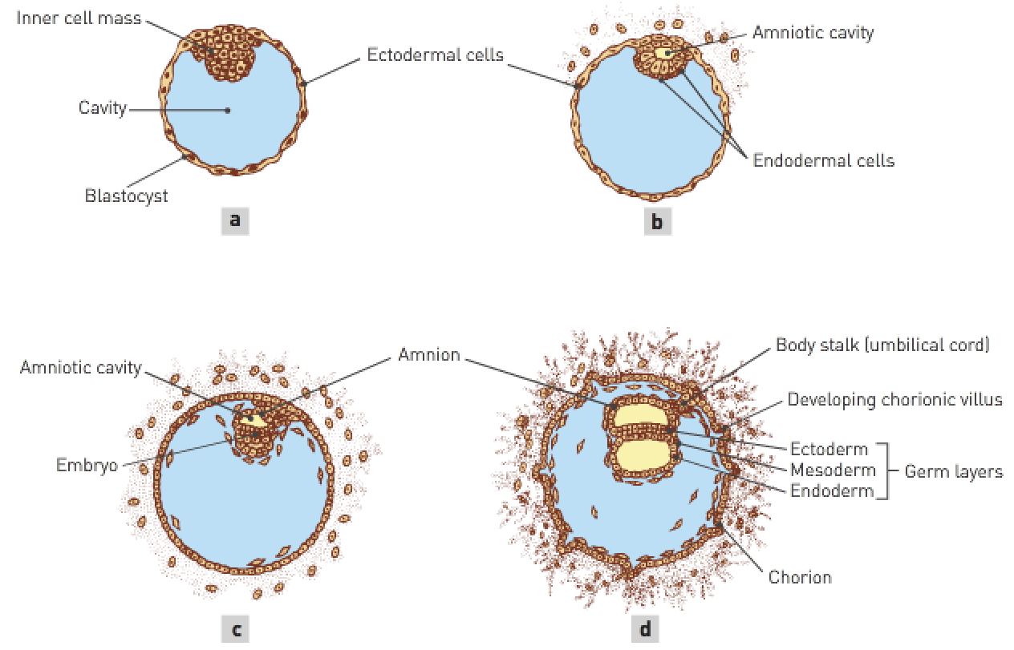
Placenta development:
- Placenta: An organ that supplies nutrients to, and removes wastes from, the foetus.
- It’s a combination of foetal and maternal tissues; the foetal proportion of the placenta develops from part of the chorion – an embryonic membrane formed from the outer cells of the blastocyst together with a layer of mesodermal cells.
- Chorionic villi are small finger-like projections that burrow into the endometrium.
- As they burrow further into the endometrium, the chorionic villi become surrounded by the mother’s blood. This increases the surface area for exchange of substances (O₂, CO₂, glucose, etc).
- Mother’s (maternal) and foetal (foetus after 2 months) blood never mix. Substances move across the cell layer by diffusion or active transport.

Placenta functions:
- Endocrine organ that releases HCG (from chorionic villi) to maintain the corpus luteum initially.
- Fully formed, it releases its own oestrogens and progesterone to maintain the endometrium.
- Provides a passage for nitrogenous wastes (urea, ammonia, uric acid, etc) to pass into the maternal blood so that the mother’s kidneys can excrete.
- Transports antibodies from the mother to provide immunity.
- Transports glucose, fatty acids, amino acids, minerals and vitamins to the foetus from the mother.
- Transports oxygen into the foetal blood supply and CO₂ into the mother’s blood supply.
- Note: Foetal lungs aren’t functioning.
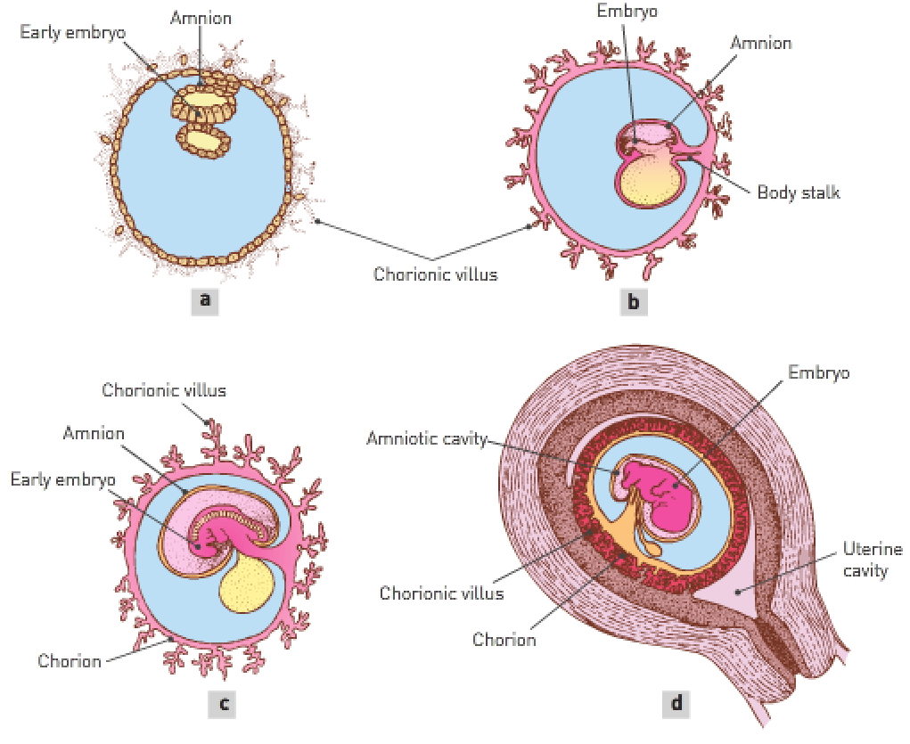
Role: | Function:
Endocrine | Secretes a number of hormones necessary for maintaining pregnancy.
Excretory | Transports nitrogenous wastes e.g., urea, uric acid, ammonia and creatinine from the foetal blood to the mother’s blood supply for excretion by the mother’s kidneys.
Immune | Transports antibodies from the mother into the foetal blood supply so the foetus has immunity to some infectious diseases.
Nutritional | Transports nutrients e.g., glucose, amino acids, fatty acids, vitamins and minerals from the mother’s blood to the foetal blood; stores some essential nutrients early in pregnancy and releases them later when the demand is greater.
Respiratory | Transports oxygen from the mother to the foetus, and carbon dioxide from the foetus to the mother.

Placenta blood supply:
- Placenta is attached to the foetus by the umbilical cord.
The umbilical cord has 2 umbilical arteries that carry blood away from the foetus (deoxygenated waste-filled blood carried away from the foetal chorionic villi).
One umbilical vein takes blood near chorionic villi (oxygenated nutrient-filled blood carried towards the foetal chorionic villi).

- When the male ejaculates, the sperm are released in the vagina at the entrance to the uterus, a process called insemination.
- Once within the vagina, the sperm travel through the cervix and the body of the uterus into the uterine tubes.
- They reach the upper portions of the uterine tubes quickly.
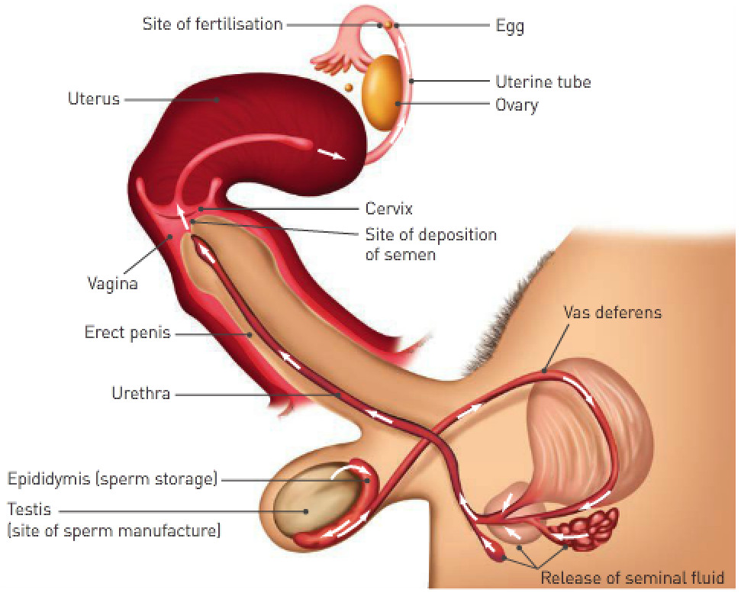
- Only a few thousand sperm reach the uterine tubes and sperm mortality is high.
- Fertilisation usually occurs in the uterine tubes when the egg is about one third of the way down the tube.
- Since ovulation, muscular contractions of the uterine tube, together with the beating action of cilia, have been transporting the egg towards the uterus.
- The mature egg is surrounded by a layer of follicle cells known as the corona radiata; an acid holds these cells together.
- The tips of sperm contain an enzyme capable of breaking own the acid that’s holding the cells of the corona radiata together; when several thousand sperm surround the egg, there’s enough enzyme to loosen the cells of the corona.

- The entrance of one sperm into the egg stimulates the formation of a fertilisation membrane around the egg, preventing the entrance of any more sperm.
- Once the sperm has entered the egg, the tail is absorbed, and the head begins to move through the cytoplasm of the egg in the form of a male pronucleus.
- The entrance of the sperm stimulates the egg (secondary follicle) to complete Meiosis II.
- The nucleus of the egg develops into a female pronucleus which fuses with the male pronucleus to form a single nucleus that now has the diploid number of chromosomes.
- Fertilisation is complete and the fertilised egg is called a zygote.

